***Report on the Aspen Music Festival***

**– 2015 Judith Clark Fellowship Recipient, Alexa Thomson**

The Aspen Music Festival is well known to be one of the most prestigious summer festivals in the world. Each year they have a programme of outstanding 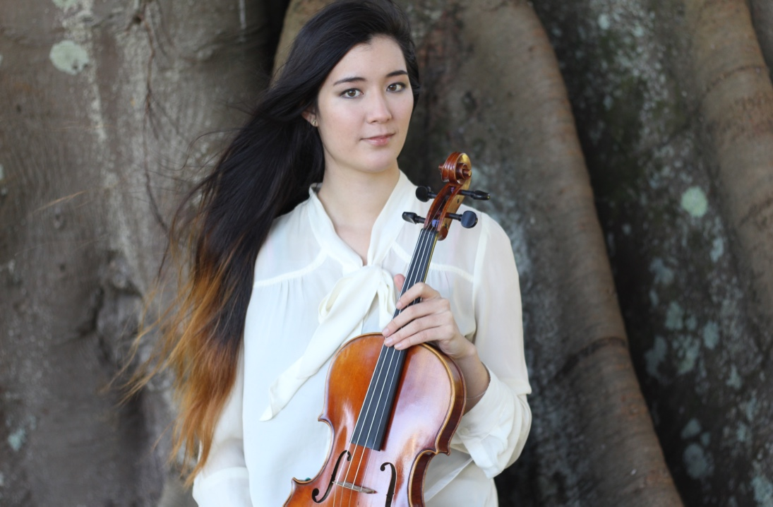guest soloists, chamber groups, conductors, and artist-faculty who teach and perform over the eight weeks, and over six hundred and fifty students attend from all corners of the world. This year I was proud to represent New Zealand within that very large student body, with my attendance made possible by the Judith Clark Memorial Fellowship.

A typical day at Aspen for the majority of instrumentalists consists of waking up in one of the student housing facilities (or off-campus rented houses), going to breakfast in one of the cafeterias (students in the housing are also on a convenient meal plan), and heading to the music school campus to practice or rehearse with one of the festival’s five orchestral ensembles. Later in the day there would likely be chamber ensemble rehearsal or rehearsal with one of the many staff or collaborative student pianists. Once a week students receive individual lessons with the faculty teacher whose studio they applied for when they auditioned, in my case, Mr James Dunham, who is based at Rice University’s Shepherd School of Music. There is also a studio class where all of Mr Dunham’s students at the festival take turns performing and offering feedback for each other. What with so many ensembles and guest artists, there are multiple concerts and events to attend every single day of the week, which all students are able to do as part of the festival. Mondays are designated days off from rehearsal, so that students can take advantage of all the scenic hiking opportunities in and near Aspen, Colorado – or catch up on personal practice if need be. Quite literally, never a dull moment!

Some of my personal highlights from this year’s festival were of course my lessons with Mr Dunham, who was a fantastic teacher and player as well as being a perfect mentor figure for his studio (of fourteen viola students) at Aspen. I also had the privilege of playing for CJ Chang (principal of Philadelphia Orchestra) and Beth Guterman-Chu (principal of the St. Louis Symphony) in master classes, having the opportunity to perform a newly-composed work with a mixed ensemble of faculty and students in one of the chamber music concerts, and seeing so many inspiring performances from the world’s top musicians, as well as my peers. For most of the summer I played in the Aspen Festival Orchestra, which is the largest ensemble and made up of both faculty (principal strings, winds/brass and percussion) and students. Each of our different viola principals brought something new to the section, and we all learned a lot by having the chance to play under such established leaders (like CJ Chang and Beth Guterman-Chu), along with all the different guest concertmasters and conductors. Students also rotate in and out of the different orchestras, and so I also got the chance to be principal viola for one of the operas, and hear Roberto Diaz when he rehearsed with the Aspen Philharmonic Orchestra.

Another valuable part of the experience was having the opportunity to talk and mingle with students from all of the top conservatories and music schools in the US, and many who study in Europe as well. I am about to apply and audition for schools for my own Masters studies, and interacting with students from institutions such as Juilliard, the Curtis Institute, the Colburn School, New England Conservatory, Rice University, Manhattan School of Music, and schools in Berlin, Vienna, and Paris gave me a much better idea of what kind of place would be right for me. Also it gave me the confidence that I should feel good about doing auditions and try to choose the right place for me, and not be afraid to apply somewhere because of being worried about not getting in or having a chance of success.

At festivals like Aspen, students achieve things they never believed possible. (From climbing 14,000+ foot mountains to performing in a minimum of eight different concerts within two months!) The teachers are so skilled, and the encouragement of being surrounded by so many driven and talented musicians – and being a part of that – creates an environment optimal for great strides in personal and musical growth in a short space of time. Lifelong connections are made, along with musical developments that will stay with me in my never-ending journey to become the best musician I can be.

I am very grateful to the Judith Clark Memorial Fellowship for making my Aspen Festival experience possible. I believe that more young New Zealanders should have the chance to benefit from such large-scale international festivals, because not only is it hugely beneficial to personal growth, but it also lets other New Zealand musicians know that actually, we have the potential to go anywhere and do anything we could possibly want to do, and that we should always dream big! Though we are a small country, our musicians deserve to have the confidence that comes with the knowledge that actually, we have a definite place in the music world.